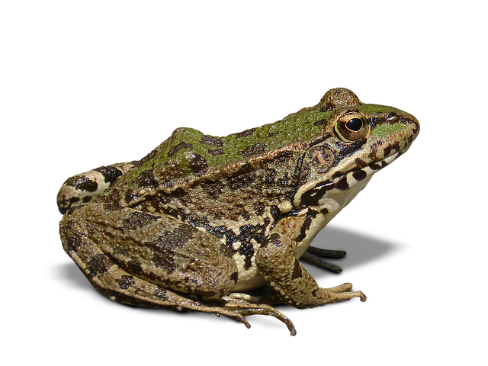PRE-K HOME LEARNING
May 18-22, 2020
CHOICE BOARD
Choose an activity to do each day. Don’t worry about crossing off the activities after you have finished. You can do these activities multiple times! We will add more activities each week. Just have fun with this! Be sure to look for updates every Monday on our teacher’s website.
Reading | Math | Science | Movement | Creativity
This week while reading and listening to the following stories, ask your children to tell you what might happen on the next page (predicting) a few times. When you are finished with the story, ask them what happened first, second, next, next and finally last to see how well they comprehended the story.  ******************  This is a story about a teensy weensy tadpole growing up.  https://www.youtube.com/watch?v=wDoc1yayWJw  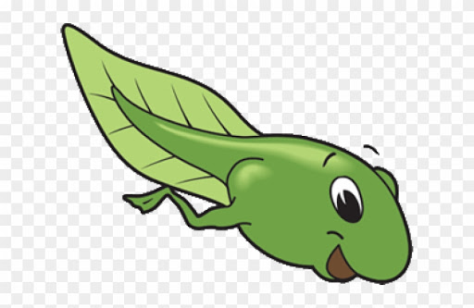******************  This is a nonfiction book with pictures of real frogs.  https://www.youtube.com/watch?v=7tIiAqmWFWo  *******************  Frog and Toad, A story for Springtime; what happens first, next and last in these two stories?  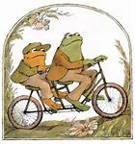  https://youtu.be/lbLl4eYfxSg  Frog and Toad; the Garden, story video:  https://youtu.be/j-4FxBAbKd8 | Practice counting with this fun game called Count the Yeti 1-10.  https://www.themathsfactor.com/games/try/?gameid=46&prefix=ZONE&config=IPG_CM_Y1_CA_001,%20support&title=Count%20the%20Yeti%201%20to%2010  ******************* Count the underwater animals and click on the number that tells how many.  https://www.topmarks.co.uk/learning-to-count/underwater-counting  ******************  First, listen to the story: Too Many Frogs. Then sort T-Shirts from around the house by BIG and LITTLE. Count and compare the number in each group. Add the two groups together and count the total.  Too Many Frogs  https://www.youtube.com/watch?v=3UnJobcVhqQ | Frogs are interesting...we can see how they change by watching this video.  https://www.youtube.com/watch?v=_YCpfzl0B4M  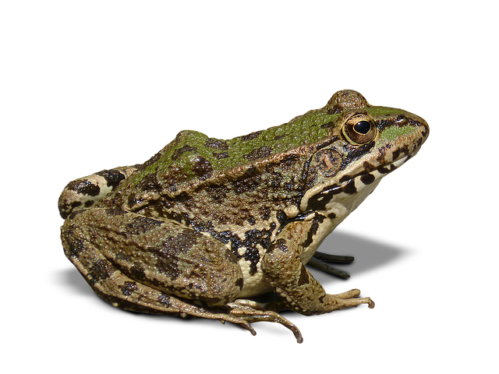  ****************** Learn all about frogs by watching this video from the San Diego Zoo!  https://kids.sandiegozoo.org/videos/fantastic-frogs  *****************  Happy Earth -  Happy Home!  Help to make the earth a better place, after watching this recyclable video:  https://youtu.be/PePymheJcbc  Use those paper/  cardboard tubes or plastic bottles to make a bird feeder or binoculars as you search for those butterflies and frogs! (See Creativity for directions)  ******************  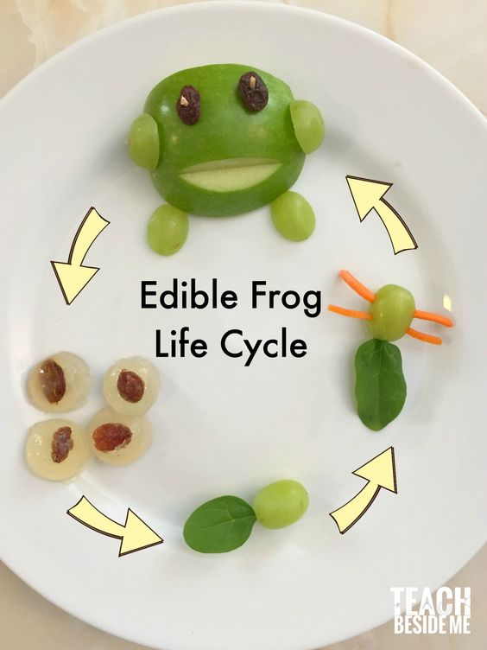  Try this snack at home and learn about the life cycle of a frog! | Here is a fun song about the life cycle of a frog!  https://www.youtube.com/watch?v=JrXww4oZrsI  **************** Make up a dance to go with the words in “5 Green and Speckled Frogs"  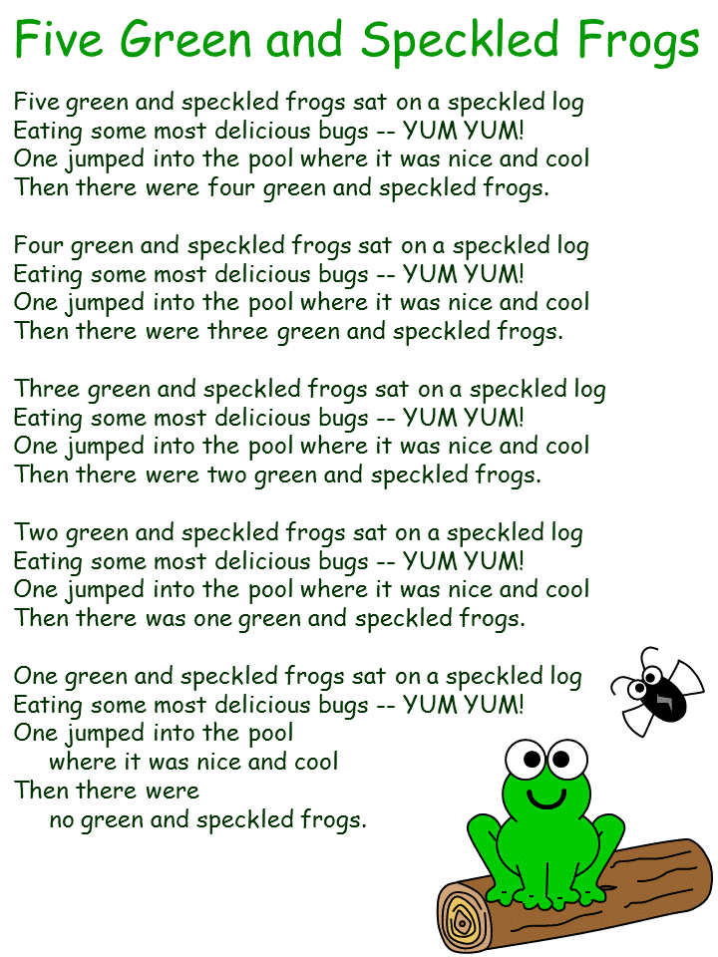  ******************  Let’s Go to the Hop! The frog hop that is! Have your children hop like frogs, counting how many times they hopped. Have a family contest to see who can hop the fastest, the longest hop, the shortest hop. Be creative and find other ways to compete! Happy Hopping!! | What can you make with a box? Watch the animated story, “Not a Box”.  https://www.youtube.com/watch?v=Nif94VQ4Xsc  Use your imagination and a box to go on an adventure. Draw a picture of your adventure and ask a parent to write down your story. Send a picture by email to your teacher.  *******************Fun with Recyclables  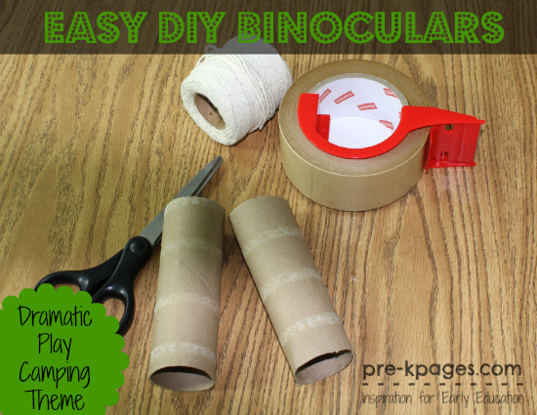  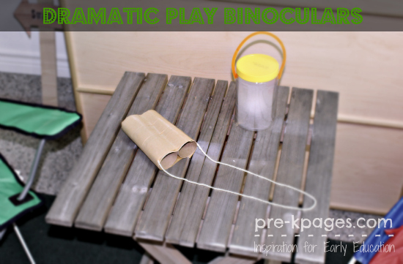  Make your own Binoculars with paper tubes, tape, string,  Crayons/markers:  https://www.pre-kpages.com/paper-bag-vest-and-binoculars/  ******************  Make a birdfeeder with paper tubes:  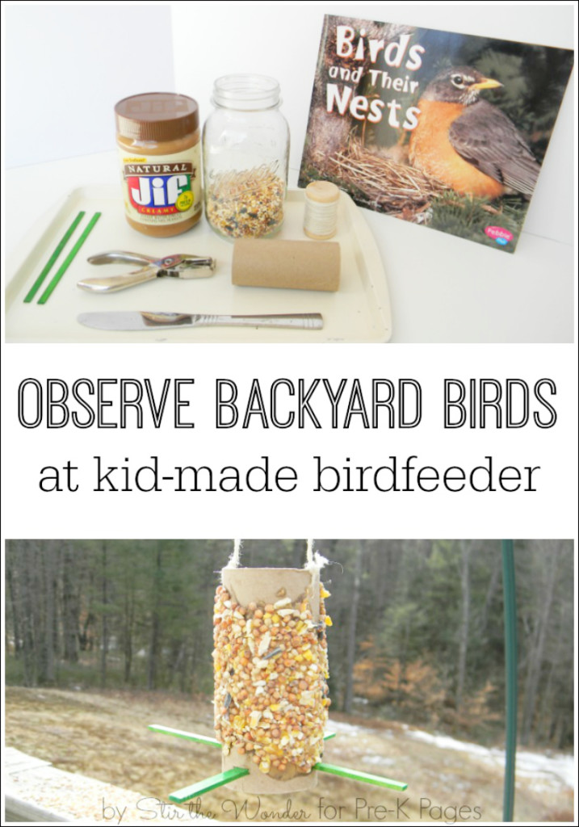  https://www.pre-kpages.com/make-a-bird-feeder-and-observe-birds/
Watch PLAYtime LIVE! on YouTube at https://www.youtube.com/playlist… or on their website at erieplayhouseplaytime.com/live  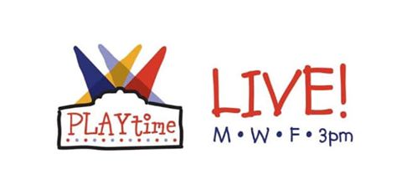*********************  Please join the WQLN Homeroom Monday through Friday from 8:00-12:00. The schedule is as follows:  Pre-K – 8:00-8:30  Science -11:30-12:00  *****************  Also visit WQLN.org under the Learning Tab for: PBS Learning Media for more fun activities. | Practice writing your numbers 0-20.  ******************  Make a set of flash cards, mix them up and tell someone what number is on each card.  *******************Practice counting from 0-25 ~ find objects inside and outside to count! | Frog or Toad?  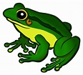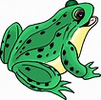  Can you tell the difference between a Frog or Toad? Watch this video to find out how, then draw or record your answers!  https://youtu.be/rVAjUSLkDLo  ********************  Use those binoculars you make to go hunting for Frogs, Butterflies, and BEARS...  https://youtu.be/_GDLXrT8KuU  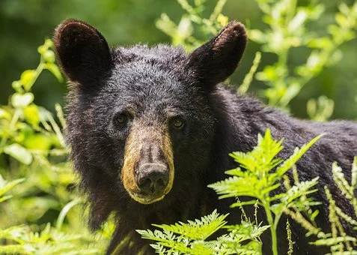  Popular Soor Preschoolers | The- Kids Music Channel • | Check out what is new this week at GoNoodle.com  ******************  Don’t forget to check out your Physical Fit and Healthy Calendar for May!! Color those squares in!  ******************  Small motor activities:  - Write your name  - Write your numbers  - Cut safely with scissors  - Play with Play-Dough or clay | Frogs on a Log  Stuff celery pieces with peanut butter and top with raisins to look like frogs on a log!  ******************* Look here at an easy way to make a frog out of paper plate.  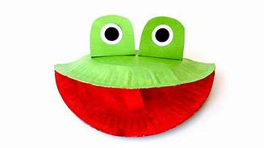  https://www.youtube.com/watch?v=dDvSZIOGRN8

